**כיצד ניתן להעביר מידע מדף PHP אחד לשני?**

A session is a way to store information (in variables) to be used across multiple pages.

Session variables hold information about one single user, and are available to all pages in one application.

By default, session variables last until the user closes the browser.

[**http://www.w3schools.com/php/php_sessions.asp**](http://www.w3schools.com/php/php_sessions.asp)

**דוגמא:**

**welcome.html**

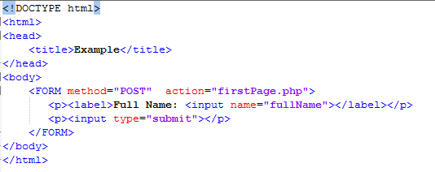

**firstPage.php**

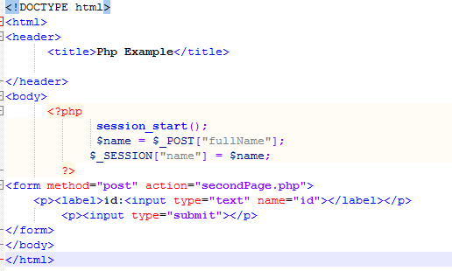

**secondPage.php**

